课时学案
课时进度 | 第＿13＿周第＿1＿课时（学期第＿37＿课时）
课 题 | Unit 6 How many?  （B）Let's talk
学习目标 | 理解和掌握句型：How many …do you have?  Open it and see! You have…
学习重点 | 理解和掌握句型
学习难点 | 名词复数的读音。
第四课时
一、读一读,连一连。
1.. 2. 3. 4.
. INCLUDEPICTURE "http://twebmail.mail.126.com/js5/Application Data/Tencent/Users/416609910/QQ/WinTemp/RichOle/`1Q5T7)1NGT~A28FUDAL@}W.jpg" \* MERGEFORMATINET INCLUDEPICTURE "http://twebmail.mail.126.com/js5/Application Data/Tencent/Users/416609910/QQ/WinTemp/RichOle/`1Q5T7)1NGT~A28FUDAL@}W.jpg" \* MERGEFORMATINET  INCLUDEPICTURE "http://twebmail.mail.126.com/js5/Application Data/Tencent/Users/416609910/QQ/WinTemp/RichOle/0KWB`R8ODADB{B40@_DH$J0.jpg" \* MERGEFORMATINET INCLUDEPICTURE "http://twebmail.mail.126.com/js5/Application Data/Tencent/Users/416609910/QQ/WinTemp/RichOle/0KWB`R8ODADB{B40@_DH$J0.jpg" \* MERGEFORMATINET  INCLUDEPICTURE "http://twebmail.mail.126.com/js5/Application Data/Tencent/Users/416609910/QQ/WinTemp/RichOle/{KXL]T(@S_SXBGJ_LP)8WYN.jpg" \* MERGEFORMATINET INCLUDEPICTURE "http://twebmail.mail.126.com/js5/Application Data/Tencent/Users/416609910/QQ/WinTemp/RichOle/{KXL]T(@S_SXBGJ_LP)8WYN.jpg" \* MERGEFORMATINET  INCLUDEPICTURE "http://twebmail.mail.126.com/js5/Application Data/Tencent/Users/416609910/QQ/WinTemp/RichOle/_4XB_U0V2FNA8FI7C@Z$BBA.jpg" \* MERGEFORMATINET INCLUDEPICTURE "http://twebmail.mail.126.com/js5/Application Data/Tencent/Users/416609910/QQ/WinTemp/RichOle/_4XB_U0V2FNA8FI7C@Z$BBA.jpg" \* MERGEFORMATINET 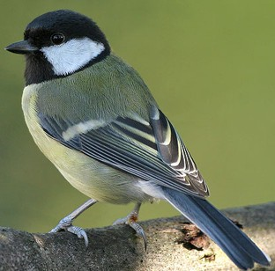

A.apple B.bird C.kite D.crayons

二、选择正确的答案。
1. ---How many cats do you see?
---_________
A. I see 12. B. I have 13.
2、---How many _______ do you have?
---I see 14 .
A. kite B. kites
3、You _____ 16 crayons.
A. have B. has

